SECTION 2.1: BUSINESS STRATEGY MAPPING
This section discusses how to create, manage, and utilize business strategy mapping to help organizations govern how they pursue their objectives. It defines strategy, discusses approaches to strategy creation, details approaches to mapping strategies, and ties strategy to other aspects of business architecture.

Defining Business Strategy Mapping
The creation of business strategy has long been recognized as a key way of helping marshal the resources within an organization towards pursuing some set of objectives. Strategy itself can be defined as:
“The pattern or plan that integrates an organization’s major goals, policies and action sequences into a cohesive whole”.
A strategy must be executed in order to achieve its objectives; consequently a use of the term strategy in business discourse often includes the processes by which a strategy is created, initiatives for executing the strategy are created, and the execution of these initiatives is supervised and monitored. Modern strategic practices consider strategy creation, initiative planning, and initiative execution and monitoring to be equally critical aspects of the practice. However, business architecture is found to be most useful in the strategy creation and initiative planning processes.
In order to provide a complete discussion of strategy, two well-founded and popular techniques for execution and monitoring are discussed at the end of this section. The Balanced Scorecard method provides guidance about setting up a monitoring and measurement system for strategic initiatives. The Hoshin-Kanri method is a management technique to insure that there is a common understanding of the strategy and the parts of a strategic initiative that must be executed in coordination by different parts of the enterprise and its partners.
Strategic objectives are achieved by making changes to the structure, operations, and resources of the enterprise. Documentation of the set of changes and the reasoning that justifies them is a strategic plan. Organizations then establish, staff, and execute initiatives and projects as a means of executing a strategic plan. The Strategy Map, as defined by Kaplan and Norton, is a well-known example of the method and the documentation. It is briefly described later in this section.
In commerce, strategic objectives are typically about the creation of value. In a non-commercial context, a strategic objective could be to defeat an opponent or to exact revenge for an insult. While such objectives may exist for individuals in a commercial enterprise, they may harm the interests of other stakeholders. In fact, most strategies, when executed, will have results that are seen as beneficial by some and as harmful by others. Likewise, a strategy may produce an immediate beneficial result to the intended stakeholders, but the result may become harmful over time.
The practice of business architecture looks at the production of value in an enterprise through value maps as defined in section 2.4. In a value stream, a type of value map, value is defined by a value item, which is an abstraction that represents how a stakeholder receives value from the outcomes of one or more capabilities associated with a value stage. A strategic objective will imply a change in some value items, including possibly the creation of new value items and even new value streams to provide those value items.
A strategic plan to achieve some objectives will contain actions that change the resources, behaviors, and other aspects of the organization units responsible for producing the outcomes that drive the value items. In business architecture maps, business units are associated with instances of capabilities and the capabilities are associated with value stages in the value streams that produce the value items.
While this technique for modeling the alignment of a strategy to business architecture perspectives may seem complicated, it is valuable because it allows decision makers to contemplate and evaluate strategies without having to immediately take the organizational structure of the enterprise into account. In fact, a high level strategic plan can be drawn by examining the value streams that produce the value items to be changed by the strategy. Then, the outcomes and capabilities associated with the value streams are examined to discover the change actions to be taken on the capabilities.

Strategy Creation and Business Architecture
The most laborious part of strategy creation is the creation and testing of the rationale that supports the conclusion that executing the strategic plan is likely to achieve the objective. This rationale must justify that each action will result in achieving a specific objective and that the sequence of actions will achieve the overall objectives. In addition, a good strategy in a competitive environment must be examined for effects of possible counter-strategies by competitors. Strategic planners must also contemplate the effects of rare but highly significant events (sometimes called “black swan” or “long tail” events).
The burden of strategy justification can be reduced by choosing an appropriate pattern or framework for examining:
- How a group of outcomes produces various levels of value for a stakeholder (a value proposition)
- Which capabilities are critical to the production of these outcomes (sometimes called a perspective)
- The resources (including financing) required to make these capabilities operational
- The behavior of other participants in the marketplace
Many such frameworks have been proposed and are currently in use. In 2004, Alexander Osterwalder published a PhD thesis in which he employed the philosophical notion of ontology to unify many of these frameworks. His thesis was titled “A Business Model Ontology …” and this title (along with subsequent publications) has given the current meaning to the term “business model”. In this document, a business model is defined as: “a description of the rationale of how an organization creates, delivers, and captures value.” In Section 3.3 of this document, the topics of business models and business model frameworks are described in more detail, along with ways to use them in conjunction with business architecture blueprints.
The business model rationale is similar to a strategy rationale in form, but it describes a hypothetical operating steady state of the business; a strategy rationale describes a set of coordinated changes to the business. The end result of a strategy can be defined by a business model that describes how the business should operate after the strategic changes have been made. Consequently, a business model can be used to test the desirability of a strategy. Insuring that the business model accurately represents the result of a strategy is a complicated task; Section 3.3 of this document provides guidance on executing this task.
A business model framework (such as the Business Model Canvas) is a template for the creation of a business model; it is based on a categorization of business aspects (such as the value proposition, the business operations, and the strategic partnerships) that need to be considered in order to assess the likelihood that the business being modeled will produce the desired values. In addition, the framework should define key interactions and relationships between the categories. These frameworks must be customized for each type of business and this customization process is greatly expedited by extracting information from the business architecture and other business sources. Value maps will define the value proposition; capability maps will define the infrastructure and strategic partnerships. The use of a business model framework in conjunction with a business architecture is discussed in Section 3.3.

Strategy and Organization Structure
While strategy has its roots in top-down approaches to alignment, organizations are increasingly finding that their plans are too volatile to be left to a central planning function. While central planning can be useful in laying foundational objectives for an organization, the breadth of knowledge required to make the myriad of decisions that lead to the realization of any strategy are too large to be taken at that level.
Decentralized or bottom-up strategy evolution can address some of the limitations of the top-down approach. In a bottom-up approach, strategy is synthesized from the range of possibilities being generated at lower levels within an organization. Decentralized strategy evolution is typically found in large enterprises with multiple business units that are not strongly economically linked.
This tension between higher-level organizational objectives and the lower-level opportunities is one that any successful strategy development process must address. This same tension also gives rise to uncoordinated strategy execution, as different business units decide to execute the strategy according to their own, restricted view of the objectives. The techniques of the Hoshin-Kanri method may be used to address such problems are gain alignment in the separate projects that make up the strategic initiative.
Business strategy mapping is, therefore, a collection of techniques that are used to enable organizations to gain visibility into the way that strategic tradeoffs are made between these competing objectives. These techniques provide both a map of how decisions have been reached as a well as a guide for what choices are currently under consideration. Taken together strategy mapping approaches can enable an organization to more effectively communicate and come to decisions about steps to be taken to pursue key organizational objectives.
Business strategy can be practiced in many ways. Many organizations operate with only the lightest level of formal strategy definition because they believe strategy stifles the innovation that is the key differentiator for their organization. Other organizations have a formal strategy management group that produces plans that are integral to the executive decision making process because they believe that the focus that comes from creating a unified approach to organizational change is what differentiates them. Strategy mapping techniques must be adapted by each organization according to its own needs and are a key element of a business architecture that relates organizational objectives and the various approaches to achieving them.
Strategy has its root in the military domain with the earliest known treatise going back to the 6th century B.C. and Sun Tzu’s The Art of War. The discipline evolved through the later works of Machiavelli, Napoleon, Rommel, and others. These military examples illustrate an approach to strategy which conceives of it as something that is fully-formed using the best efforts of some key group within an organization. However, even with military thinkers, it has long been clear that this viewpoint is short-sighted. General Dwight D. Eisenhower famously commented:
“In preparing for battle, I have always found that plans are useless, but planning is indispensable.”
In fact, for many organizations, the exercise of planning remains much more valuable than conforming to any particular strategic plan since those plans quickly become obsolete. Research has shown that organizations develop strategies through the incremental identification of:
- What an organization might do
- What an organization can do
- What an organization’s leadership wants to do
- What an organization should do
There have been many approaches developed to assist in creating a strategy over the last few decades. Most, if not all, strategic approaches see strategy as a series of overlapping perspectives of an organization that represent different imperatives and result in various courses of action. This section discusses various types of strategy mapping approaches and applications.

Benefits of Strategy Mapping
A structured business strategy covers a variety of viewpoints that are interlinked in order to deliver a cohesive approach to pursuing that organization’s objectives. These interlinked points of view capture the balance of forces that every organization must consider when it is delineating its strategy. No single point of view can stand on its own. An integrated strategic framework delivers the following benefits:
- A strategic mapping framework supports organizational alignment. Strategies are only as effective as the ability of an organization to align itself behind them. Gaining alignment within an organization involves much more than simply communicating a strategy from the highest levels down to lower levels within an organization. A strategic mapping framework allows a much larger part of an organization to understand and act on ideas about how an organization could be aligned to deliver its objectives. Creating this kind of framework opens up a discussion of the implications of the strategic directives. This opening allows strategic gaps to be identified early, blockages to alignment to be located, and the combined knowledge of a much larger organization to be brought to bear upon a proposed approach.
Strategies lacking a communication framework that offers deeper visibility into an organization are likely to have limited buy-in beyond the highest levels of management. These kinds of strategic initiatives are likely to face organizational resistance that can take many forms and can be difficult for all but the most powerful executive to overcome. Communication is the most fundamental aspect of any organization’s successful strategy work.
- A strategic mapping framework improves communication and fidelity of objectives. While business leaders are typically engaged in the development of business strategies, most executives agree that their organizations fall short in the execution of the strategy. One of the main reasons for this deficiency is the loss of fidelity of strategic objectives. As strategy is communicated through the layers of the organization, each layer applies its own perspective and interpretation. Some estimates are that roughly half of the original strategic intent makes it to the initiative implementation level. A strategy mapping framework formalizes the strategic intents of executives and links them to specific, unambiguous, objectives which can be communicated more effectively.
- A strategic mapping framework assists organizations in adapting rapidly. With the pace of innovation and the rate of competition increasing in many industries, the ability to innovate is becoming more essential every day. Traditional strategic approaches tend to be very top-heavy and ill-suited to a rapidly changing environment. A strategic mapping framework provides a structured approach that can help organizations incrementally adapt to changes by creating clear relationships among elements within the strategic framework, which permits organizations to incrementally reassess ongoing initiatives against evolving objectives. Such a framework can also help by allowing new business opportunities that are recognized at lower levels within an organization to be identified at those levels, providing much earlier opportunities for strategy adoption.
- A strategic mapping framework enables the rationalization of initiatives. Organizations make use of various governance frameworks including gated approval processes, threshold ROI analysis, and cost-benefit evaluations in order to ensure that initiatives are aligned with strategy. However, assessment of initiatives that have already been launched is typically limited to evaluating whether milestones and cost targets have been met. This approach provides limited opportunities for organizations to adjust these initiatives to reflect changes in the organizational environment or organizational objectives that occur after initiatives are launched. By using a strategic mapping framework, organizations gain the ability to create governance frameworks that support regular reevaluation of initiatives for conformance to the then-current strategic objectives. This approach enables the rationalization of ongoing initiatives.
- A strategic mapping framework supports capability-centric investment. While core investments are generally fully vetted by organizations, there are many smaller investment decisions that have much less visibility. Frequently these investment decisions are not even recognized as such. By tying all decisions to create or enhance capabilities into a strategy mapping framework, it becomes possible for organizations to gain better visibility into these investment decisions and to assure alignment with capability investment decisions at the strategic level. Mapping of initiatives to strategy is discussed further in section 2.7 Initiative Mapping.
- A strategic mapping framework provides the ability to monitor an organization’s progress towards strategic objectives. One of the greatest obstacles to achieving strategic objectives is the inability to drive alignment with those objectives deep into an organization. A strategic mapping framework provides the infrastructure to allow organizations to examine the linkage between the strategic objectives and the details of how those decisions are being decomposed into lower level objectives, mapped to capabilities, value streams, business units, and information concepts and pursued via initiatives. This framework enables organizations to build strategic dashboards to allow rapid assessment of the current state of an organization’s activities to achieve its strategic objectives.

Principles of Strategy Mapping
While virtually all organizations have some level of formal strategy analysis, integrating these efforts into a cohesive strategy framework remains a challenge. Establishing certain principles facilitates efforts to integrate those strategic objectives into a framework that allows them to be integrated deep within an organization. The following principles define the key activities required to create this kind of framework.
1. Business strategies relate to a particular “community of interest”. There is no such thing as a strategy that makes sense regardless of the parties that have a stake in the outcome of that strategy. Because of this, all strategies must begin with a definition of the set of the stakeholders whose value proposition may be impacted by the strategy being defined.
In the simplest case, a commercial organization has the following stakeholders: customers, management, employees, and shareholders. However, this simple case is seldom the whole picture. As organizations move to a more virtual way of conducting business, the set of stakeholders that are involved often includes partners whose integration delivers increased value to customers beyond that which the organization or the partner could deliver separately. Within this type of integrated value system, a strategy must address the way that all stakeholders respond to that strategy.
2. Business strategies are created to respond to the external environment. No strategy can be expected to be achieved without considering the environment in which that strategy will have to operate. The ecosystem an organization exists within consists of a range of different external constraints and opportunities. Identifying those areas where opportunities exist and where an organization is positioned to take advantage of them is a core part of any effort to define a strategy. The environment of an organization contains a wide variety of considerations, including:
- The relative strength of an organization’s capabilities as compared to rival organizations
- Opportunities to address underserved or new market segments
- External directives, such as regulatory regimens
- Pricing power, both in regards to customers and in regards to suppliers
- Barriers to entry to a marketplace
- Opportunities to disrupt an existing market by introducing new business models driven by items such as technological innovation
3. Business strategies are evaluated using value analysis. A business strategy is an approach that enables an organization to preserve and increase the value it delivers to its identified stakeholders. Because of this, value analysis is the key approach for evaluating the relative attractiveness of the various strategic choices that an organization faces.
Many organizations focus their analysis of value on the goods and services delivered and the money transferred among the various parties. However, value analysis goes beyond examining the simple economic exchange captured in financial transactions. To avoid commoditization of an organization’s offerings, it is essential to create strong market differentiation. One of the most powerful ways of achieving this is for an organization to create an ecosystem of value.
Value analysis is the next step once an organization has identified the environmental elements that structure where it can differentiate itself. As various strategies are identified, a rigorous examination of how value is generated can be used to identify capabilities that should be targeted for investment and potential partnering opportunities. More detailed discussion of value analysis is provided in section 2.4.
Principles 1-3 in combination provide insight into what an organization might be able to achieve.
4. Business strategies leverage and build upon existing organizational capabilities. A successful strategy must be able to be reached by the organization within the timeframe defined for that strategy. Determining whether an organization can implement a particular strategy involves understanding the existing capabilities within an organization.
Many organizations have yet to clearly identify the core set of capabilities that provide them the ability to differentiate themselves. Research has shown that most organizations have a relatively small set of core capabilities that differentiate them and that there is a “coherence premium” for organizations that successfully identify these core capabilities and align their strategies to them.
Business strategies must be tested against the core set of capabilities an organization possesses to determine if the strategy is reachable and coherent. A strategy that requires too rapid an evolution of an organization’s capabilities is much more likely to fail. A strategy that requires investment in non-core capabilities is likely to cause an organization to result in diminished effectiveness and efficiency. In addition, it is likely to undermine the coherent message that an organization’s members must communicate in order to maximize the alignment of activities within the organization that produce the value items the organization has targeted. Value item, which is discussed in more depth in section 2.4, is defined as “the judgment of worth, made by an individual or organization, attached to something tangible or intangible and attained in the course of a particular interaction with one or more other parties.”
This principle focuses on what an organization can achieve.
5. Business strategies are realized through the creation of initiatives that target specific measurable outcomes. A business strategy is a way of defining how an organization intends to leverage and enhance its existing capabilities in order to deliver new differentiated value. However, a strategy itself is nothing more than a set of guidelines for the new value proposition that is being targeted. In order to achieve a strategy, an organization must launch one or more related initiatives.
Managing how initiatives deliver on an organization’s strategy is itself a complex undertaking. It is frequently the case that a strategy cannot be pursued by simply creating an initiative designed solely for the purpose of achieving the related strategic outcomes. An outcome is “an end result or final product that is a consequence of an event, action, or a series of events/actions.” For example, a strategy, an initiative, or a value stream would produce an outcome.” In fact, it is typically the case that the majority of initiatives underway within an organization are operationally focused rather than strategically focused. These operational initiatives often represent the largest portion of an organization’s initiative budget and often touch upon processes across a broad swatch of the organization.
The relative size of operational initiatives versus strategic initiatives means that strategic outcomes must be at least partially achieved within the context of operational initiatives. This situation makes it imperative for organizations to identify the intersection between strategic and operational initiatives to assure that a coherent path towards strategic objectives is being taken. Because strategic objectives are constantly evolving, this process of aligning initiatives needs to be institutionalized into a continuous effort through the creation of a governance structure.
This governance structure must identify and allocate specific objectives that support strategic outcomes for any significant initiative. Each initiative should be responsible for regularly analyzing and evaluating the manner in which it is pursuing these objectives in order to continually realign the organization either by modifying the initiative or triggering a reevaluation of objectives in the strategic plan.
6. Business strategies represent a portfolio of approaches to pursuing objectives. It is rarely the case that an organization finds an opportunity to pursue an objective that does not involve some tradeoff with another potential objective. Because of this, the creation of a business strategy must include the evaluation of how various strategic objectives interact with each other.
The interaction between strategic objectives can be broken into two broad categories: benefits and risks. While it is a common simplification to think of benefits as being the same as the income stream accruing to an organization, in practice the determination of benefits can be a complex exercise in its own right. The intangible value of items such as customer loyalty and brand value are examples of the difficulty assessing benefits involves. Projecting benefits into the future is also difficult; both environmental issues and market and product maturation make extrapolating from the current state problematic.
The problematic nature of defining and evaluating benefits emphasizes the need for any strategy to also assess the associated risks. High risk strategies are often successfully explored using pilot programs, test markets, or other similar approaches to help gauge the likelihood of the strategy succeeding before an organization commits significant resources. Thus, a strategic approach involves balancing the set of objectives that yield incremental benefits with a set of smaller, more risky objectives that offer potential greater benefits, but with much lower certainty.
This principle focuses on what an organization wants to do.
7. Business strategies are only as good as the ability to measure progress towards them. Organizations that identify promising strategies often struggle with how to determine if their organization is successfully pursuing their strategy. Unfortunately, it is seldom possible to directly measure progress towards strategic objectives. Instead, organizations are required to develop a range of measures that serve as some sort of proxy for these objectives.
The commonly used “customer satisfaction” measure is a good example of this problem. There is no way to directly determine how satisfied a customer is. In fact, it is not entirely clear that the customers themselves always have a good understanding of this. Asking customers about satisfaction appears to be the most direct way of discovering this measure, but customers who provide this information tend to self-select and may not necessarily be truthful for any number of reasons.
Since the achievement of strategic objectives often cannot be directly measured, it is essential that organizations develop a framework of potential measures that capture behaviors that are expected to move in concert with the desired objective. It is also important to take into account that measures contribute towards objectives over differing timeframes. For example, some measures may have an immediate impact while others may only influence the objective over a period of years. Defining these measures involves identifying obtainable measures as well as creating a framework that captures the relative contribution of each measure and the expected time period for such a contribution.
8. Business strategies are dynamic and continuous. The environment that an organization operates within is never static. Because the environment is one of the primary drivers for strategy development, this implies that a strategy must be dynamic to address these environmental changes. The continuing evolution of strategy makes it essential for organizations to develop effective communication approaches to ensure that evolving strategic objectives are regularly and rapidly communicated throughout an organization. Strategic planning is continuous rather than a yearly or biennial exercise. The current strategies are always being evaluated and changed when needed.
While the environment is a key driver for strategic change, another important driver is organic innovation. Organic innovation happens within an organization when opportunities for changing the value being delivered to a community of interest are discovered outside the senior management ranks. The ability to recognize and capitalize on organic innovation is essential for organization to supplement the necessarily limited visibility into opportunities that senior management driven strategy possesses.
In order to be successful, an organization’s strategies must be socialized and pursued throughout the organization in a timely manner. With the rapid evolution of where competitive advantage can be found, the need to effectively communicate strategy and dynamically respond to changes becomes essential. This need exists regardless of whether strategic objectives are developed top-down by senior management or are pulled-up from potential opportunities identified at lower levels within an organization. Section 2.3 provides organization mapping approaches that provide a basis for innovation to emerge at the periphery of an organization, versus being limited to top-down options.
9. Business strategies are developed using a variety of analytic frameworks. Business strategy development cannot be performed using any single, universally accepted, prescriptive approach. Variations in how strategy is formed are driven by elements as diverse as industry and market, existing organizational capabilities, and the individuals participating in the strategy process. These variations leave the choice up to each individual organization to decide which specific analytic frameworks should be used to define strategies.
This variation in analytic approaches does not imply that there is no commonality in how organizations go about driving towards their strategic objectives. The way in which strategic objectives are decomposed into lower level objectives, how the resulting value is captured by mapping the changed value delivered to the various stakeholders, the ability of the organization’s existing capabilities to deliver these expected outcomes, and the validation of the objectives in respect to the environment in which the organization operates, all remain consistent.
This principle focuses on what an organization should do.

Strategy Mapping Frameworks Overview
There are multiple approaches to identifying, mapping, and leveraging business strategy. These approaches are expressed through various mapping frameworks, each of which has certain uses and strengths. The central focal point, however, is on strategy mapping. Strategy mapping articulates a strategy in such a way that it can be readily interpreted and acted upon. Strategy maps vary but are essentially a graphical depiction of goals, objectives, and related courses of action, often aligned against an organizational backdrop. Strategy mapping has existed in one form or another for some time. Sample strategy mapping frameworks are shown below.
- Ansoff Product/Market Grid
- Strength/Weakness/Opportunity/Threat (SWOT) analysis
- Five Forces Model (Michael Porter)
- Norton Kaplan Strategy Map
- Business Motivation Model (BMM)
- Hoshin Kanri
The Ansoff Product/Market Grid, SWOT analysis, and Five Forces Model enable strategy formulation by highlighting focal points that executives should incorporate into strategic planning efforts. SWOT, for example, surfaces internal and external perspectives that should be capitalized upon or otherwise addressed. The Five Forces Model focuses threats through a finer lens of competition, buyers, and suppliers.
The Norton Kaplan Strategy Map, on the other hand, “provides the discipline to ensure that the formulated strategy has specific objectives for shareholders and customers, an explicit customer value proposition, the critical internal processes for creating and delivering the value proposition, aligned human resources, information technology, and organization culture”. In other words, the Strategy Map offers a more complete, in-context perspective on business strategy.
The two final strategy mapping categories in the above list provide additional perspectives. The Business Motivation Model (BMM) provides a mapping between the “ends” to be achieved (i.e., goals and objectives) and strategies and tactics (i.e., the “means”) needed to achieve those ends. Hoshin Kanri provides similar cross-mapping concepts including tying mission, goals, and objectives with action items and key performance indicators (KPIs). These two mapping approaches further implementation planning and are discussed later in this section.
The end result of any strategic mapping process, regardless of approach taken, is a clear set of measurable objectives, priorities, and action items that management can act upon to deliver change. The framework discussion is categorized by differing strategy mapping approaches. We will first take a look at the three approaches used to identify the opportunities to be addressed by the business strategy: the Ansoff Product/Market Grid, SWOT, and the Five Forces Model. The Norton/Kaplan Strategy Map, BMM, and Hoshin Kanri are addressed in separate sections that follow because they focus on strategy mapping topics that go beyond opportunity / risk / threat analysis.
Strategy formulation is a creative task and research on creative problem solving has shown two general approaches. This document will term these approaches as the “planning approach” and the “design approach”. The planning approach is characterized by rather specific goals and an analytic process that predicts the outcomes for a small number of choices, allowing the decision maker to choose the strategy which provides the best value for an acceptable level of risk. The design approach is characterized by less specific goals and multiple goal opportunities and an exploratory process that aims to quickly eliminate infeasible strategies without having to conduct a detailed analysis. It is not possible to define these approaches so that there is a clean separation, and, in practice, they are often used on combination, which one approach chosen as the initial, dominant approach.

The Planning Approach
Many approaches to strategy development embody ways to identify differentiated market strategies as the key entry into the process. This approach is sometimes referred to as the “planning” approach to strategy because it first identifies high level opportunities, then establishes objectives based on the opportunities, and finally develops possible courses of action to achieve those objectives. This categorization reflects the focus on analyzing market opportunities as the core analytic approach for strategy development. There are three mapping frameworks that characterize the planning approach.

Ansoff Product/Market Grid
The Ansoff Product/Market Grid, shown in figure 2.1.1, represents one of the earlier attempts to provide just this kind of structured approach by suggesting that organizations examine four quadrants that combine New Markets / Current Markets and New Products and Services / Current Products and Services axes to produce four distinct value propositions (Market Penetration, Market Development, Service/Product Development, and Diversification).
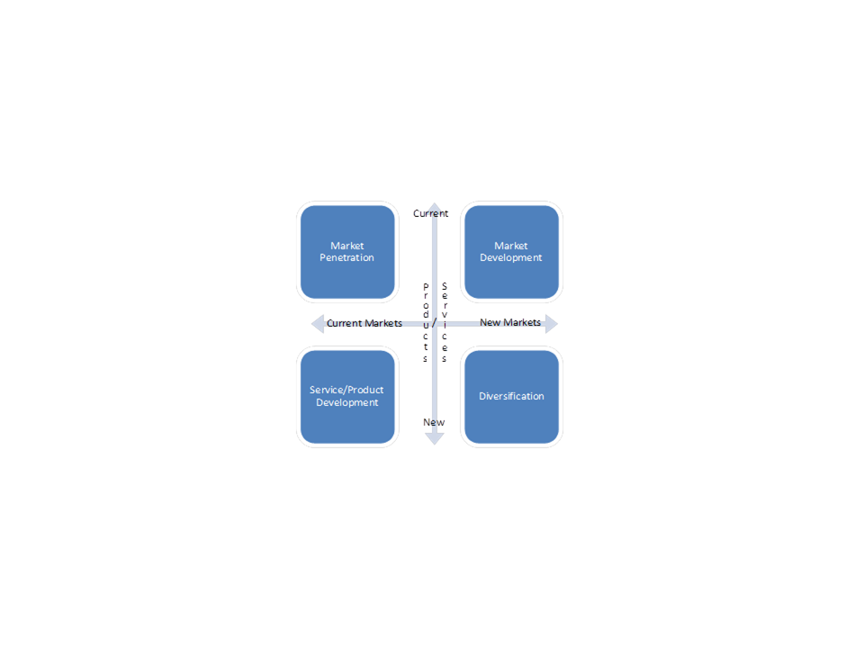
Figure 2.1.1: Ansoff's Product/Market Grid
The Ansoff Product/Market Grid demonstrates early thinking on what should go into a strategic planning discussion. As we will see below, these early analysis approaches have matured in various formats. While relatively simple, the Ansoff Grid provides a quick outward-facing market-oriented view of where an organization might find potential opportunities. Unfortunately, the simplicity of the Ansoff model limits its applicability. Many organizations face complex combinations of the four quadrants, a situation that the Ansoff approach is unable to address.

SWOT Analysis
In the late 1960s, the SWOT technique (Strengths, Weaknesses, Opportunities, and Threats) emerged. The SWOT framework, shown in figure 2.1.2, followed a path similar to Ansoff’s by focusing on a top-down planning approach. However, the SWOT technique uses different perspectives than Ansoff’s grid. SWOT combines lenses for an organization’s capabilities (strengths and weaknesses) combined with an analysis of the environment (market opportunities and threats).
 | Helpful | Harmful
Internal | Strengths | Weaknesses
External | Opportunities | Threats
Figure 2.1.2: SWOT Matrix
SWOT analysis is widely used and accepted across many industries. Unlike the Ansoff grid, SWOT incorporates both outward facing as well as inward-facing perspectives. Once again the simplicity of the approach makes it an attractive tool, but it is not resilient enough to enable a strategic framework to be built that can be used to guide and govern an organization.

Five Forces Model
The publication of Michael Porter’s book Competitive Strategy: Techniques for Analyzing Industries and Competitors greatly expanded upon the approaches pioneered by the earlier authors. Porter’s approach further subdivided the competitive environment into five forces: Potential Entrants, Suppliers, Buyers, Substitutes, and Industry Competitors, as shown in figure 2.1.3. His set of competitive differentiators also provided a set of potential value items that organizations could assemble to take advantage of the market situations that were identified using his framework.
The Five Forces Model provides a comprehensive set of perspectives sufficient for organizations to build a robust strategic framework. What the framework lacks is both the assessment of what an organization can do and how the objectives of the organization link to these perspectives.
Figure 2.1.3: Porter's Five Forces Model

Planning Approach Summary
Ansoff, SWOT, and the Five Forces Model are limited by the lack of an approach to integrating the value, capabilities, objectives, and environmental considerations. Several approaches have been taken to attempt to address these limitations. Strategy maps are an attempt to link the objective-driven balanced scorecard approach to planning. However, the strategy map does not provide a strong framework for linking the environmental choices that the planning approaches emphasize. Porter’s Value Chain work also provides a framework for integrating various pieces of a strategic approach. His representation of core and non-core activities corresponds roughly to the concept of capabilities. By linking differentiators to these activities he identifies the relationship between capabilities and the value items that are produced by them.

The Design Approach
On the other hand, there are approaches that focus on business motivation aspects of an organization (e.g., vision, mission, goals) as the core analytic concept rather than on market analysis. In this kind of approach, strategy builds upon an organization’s existing high-level objectives to provide an actionable path or set of paths towards achieving all or part of those objectives. These higher level objectives often take the form of vision and mission statements that describe how an organization wants to be perceived externally and the organization’s core value proposition respectively. Because the objectives are high level, there are often many strategies that appear to offer the potential to realize them. The approaches are characterized by methods that quickly describe each strategy and test it for feasibility and likelihood of realizing desirable and undesirable outcomes. This approach to strategy creation involves trial and error, whereas the planning approach derives the strategic changes directly from an analysis of the market and business operations.
Kaplan and Norton use Strategy Maps as a way to describe a strategy option in a design approach to strategy formulation. They are easy to draw and capture the essential rationale of the strategy option. The strategy maps that describe various strategy options can be compared and their differences examined as a way to assess the impacts of different strategies on the business.
More recently, business model frameworks such as the Business Model Canvas have been developed to facilitate the design approach. The Business Model Canvas is described in more detail in Section 3.3 of this document, but a brief overview is given here to illustrate how aspects of a business model are defined. The Business Model Canvas defines nine building blocks that interact to determine how an enterprise may achieve its objectives:
- Key partners
- Key activities
- Key resources
- Value propositions
- Customer relationships
- Channels
- Customer segments
- Cost structure
- Revenue streams
The architect will collect information about each of these aspects and the relationships between them. This can be as informal as sticky notes or one of the existing software tools that support additional details and analysis may be used. This framework evokes more detail about the customer relationship and value proposition than some other frameworks. As a consequence it has been popular in the establishment of strategy for startups.

Three Components of Strategy Mapping
Given the variety of approaches to creating a strategy, the business architecture practitioner needs a way to map strategy that is compatible with one (or more) of these approaches. The strategy map has three components: an objective map; a linking between the objective map to core business architecture domains, particularly capabilities and value streams; and one or more analyses that evaluate the objectives and mapping in the context of the competitive marketplace and the economic, legal, and societal environment.

1. Mapping Objectives
The core component of strategy is an objective and action chain in which a course of action is defined that will plausibly result in a achieving the desired objectives. The desired objectives of the objective maps can be estimated and become measurable. The actual results of a project can be measured and compared with the objectives to determine if the project is achieving the objectives of the strategy and to identify corrective changes to the project.
The top level objective in the chain is frequently called a "strategic objective", and an objective map is created with the purpose of achieving this objective. These objectives are being pursued to change the "status quo" in the enterprise, but often more detailed objectives must be pursued to achieve a higher level objective. For example, "improving response to customer issues" may require "implementing an issue management IT system”, "training customer-facing personnel”, and "creating a capability for resolving issue escalations”. In general, an objective map will consist of a tree-like structure, rooted at the strategic objective. An example of this tree-like structure is shown in figure 2.1.4.
Figure 2.1.4: Objective Map Example
However, enterprises rarely have a single strategic objective, and objectives in one strategy may oppose desirable objectives that are part of other strategies. For example, "training customer-facing personnel" also has the consequence of making these persons unavailable for their usual business activities. A strategy portfolio is a collection of objectives linked together by objectives that support or oppose the objectives associated with other strategies.
Objectives in a strategy will often have pre-conditions that must be met before they can be carried out. In the objective maps, some of the objectives supporting one objective will satisfy the pre-conditions of another objective. Some of the pre-conditions may already be met in the "status quo" of the enterprise.
One of the most well-known versions of the objective map is Norton and Kaplan’s Strategy Map, discussed later in this section. The strategy map represents objectives as oval shapes. An objective with a pre-condition upon another objective’s attainment has an arrow pointing to the objective which has a pre-condition. The arrow originates from the objective which will satisfy the pre-condition. The Norton/Kaplan strategy maps combine multiple elements of the overall approach to strategy mapping and will be discussed in more detail later in this section.
It is not necessary to completely identify all of the objectives, the support/oppose relationships between objectives, and the preconditions for actions. It is typical to only identify the important actions (i.e., those that may be difficult to execute), the important objectives, and important oppositional/supportive relationships between objectives. The ability to distinguish the important and unimportant objectives comes with experience and an understanding of the strategy approach being used. Objectives that are found to be unimportant can always be discarded from the map to avoid distracting the business architecture practitioner and the business stakeholders who will evaluate the strategy proposal.
Every objective map has an associated rationale – a collection of plausible reasons why the actions should result in achieving the objectives and why the actions may not result in achieving the objectives. The rationale is typically surfaced and discussed in the meetings and discussions leading to the creation of the strategy, but is often not recorded. If it is not recorded and distributed with the strategy for action planning, there is a risk that executives and managers receiving the strategy will assume a rationale different from the rationale used to create the strategy. Balanced Scorecards and Hoshin-Kanri, discussed later in this section, include practices to insure that the strategy rationale is also understood.
The strategy rationale contains information that will be useful in linking the strategy and the business architecture. In addition, the rationale contains information that helps link the strategy to the environmental factors that may support or disrupt the strategy.
Various approaches have been taken to help organizations understand the tradeoffs and conflicts between simultaneously pursuing multiple objectives. Some of these approaches involve helping organizations visualize and brainstorm the conflicts in order to help find possible non-conflicting resolutions. These approaches include P-TRIZ and the Current Reality Trees found in the Theory of Constraints work. Current Reality Trees are strongly related to objective maps. In addition, a great deal of work has been done to create a formal mathematical basis for decision making. These approaches involve pair-wise comparisons of individual options at multiple levels to develop objective weightings of the relative value of alternatives. The most prominent of these approaches are the Analytic Hierarchy Process (AHP) and Analytic Network Process (ANP) .

2. Linking Objective Maps and Capability/Value
An objective is related to some value items in value streams. Typically, each low level objective in an objective map will relate to a value item in a value stream. Figure 2.1.5 shows an example based on the objective map example previously depicted in figure 2.1.4.
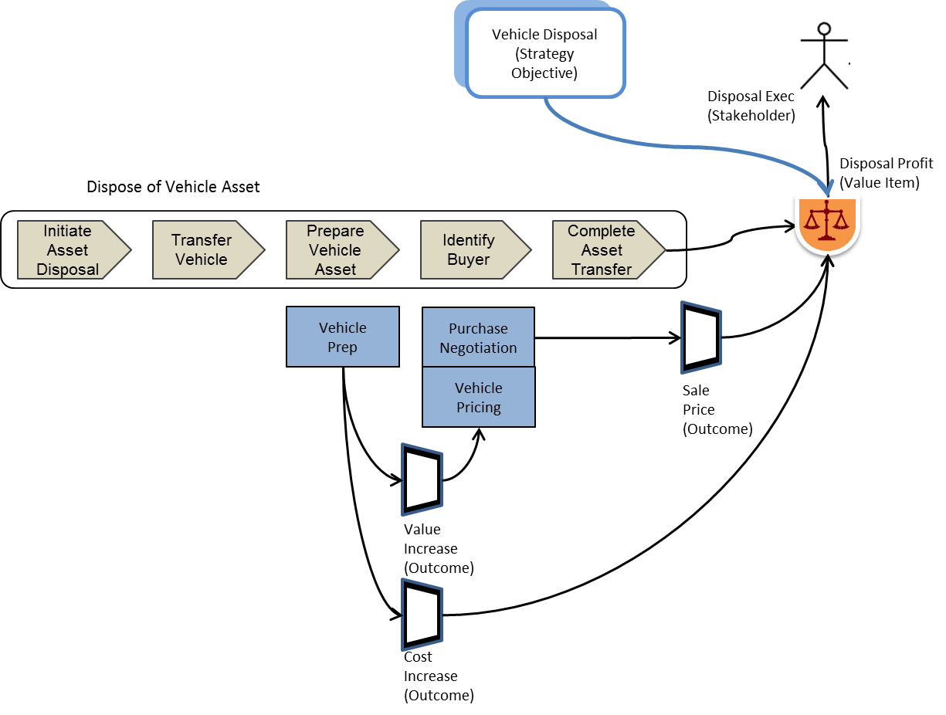
Figure 2.1.5: Objective Relationship to Value Stream
The primary value item of the “Dispose of Vehicle Asset” value stream is the Disposal Profit, whose primary components are the sale price of the vehicle and the cost of the vehicle. The cost would include the cost of acquisition and depreciation as well as the cost of maintenance; figure 2.1.5 has been simplified for presentation as an example. The outcomes of various capabilities are assigned a value to a stakeholder by the value item, as shown figure 2.1.5. To effect the objective, the strategic course of action must alter these outcomes by changing the capability instances that produce these outcomes.
A capability instance, discussed further in section 2.2, is defined as “a distinct implementation of a capability, as it is utilized within a specific business unit, value stream, or other deployment.” By tracing out the impact in this way, the business architecture practitioner can flesh out details of the course of action, consider alternative actions (e.g., increasing maintenance efficiency), and determine the capabilities and other business components, such as resources or assets, that will be affected.
Carrying out a strategic course of action requires resources of various types. The skills and information resources to carry out an initiative strategic course of action are likely to be found in business units that implement capabilities that can execute the course of action (e.g., project offices) or can perform related actions. In addition, the strategic course of action will alter the skills, resources, processes, and management practices of business units that are to be changed in order to achieve the strategic objectives. Matching strategic courses of action to capabilities that will carry out the course of action or be altered by the course of action allows the business architecture practitioner to estimate the degree of change to a business that will be needed to execute the strategy.
To be clear, it is not the capability that is being changed by the strategic course of action, but rather the business unit components that provide resources to the capability instances given the task of carrying out the work needed to achieve the outcomes of the capabilities. To avoid complexity in the descriptions that follow, strategic actions will be said to “be carried out by” capabilities and will be said to “alter, remove, or create” capabilities. The reader should understand that these phrases refer to the business unit components assigned to carry out the actions of the capability instances associated with the capability map.
Perhaps the strategy requires a capability that has no capability instance or no business unit components in the enterprise assigned to carry out the work of the capability; these capability instances and business unit components will have to be created in order to successfully execute the strategy. In many cases, however, business unit components assigned to capability instances need to be improved or transformed to enable delivery of a given strategy. Analysis of the skill and other resource requirements of a course of action will be essential inputs into defining the capability instance to be created or transformed.
In the business architecture, the strategy map and the capability map are joined by relationships suggesting the meaning of the match. For example, a strategy action may be "carried out" by a capability, or a capability may be "augmented to achieve a strategic objective" or "created to achieve a strategic objective”. Some strategic courses of action may result in "outsourcing a capability" or "eliminating a capability no longer needed”. Finally, it is also the case that capabilities are required to direct the execution of strategic courses of action. These are usually executive capabilities. Linking an executive capability to a strategic initiative makes it clear what part of the enterprise is responsible for the action.
If the course of action calls for additions to the capability instances, the business unit must be able to marshal resources to support these additions. This is an important test of feasibility for a strategy. Suppose that the strategic objective is to increase margins and create more customer satisfaction, and the strategic initiative deploys application engineers to work with the customer's engineers. Execution of the initiative to deploy application engineers may require hiring many such engineers. The ability to hire will be reduced by lack of availability. If it is discovered that a sufficient number of engineers cannot be hired, the corresponding objective must be abandoned or revised. The linkage of strategic objectives to capabilities creates the signposts needed to carry out feasibility and capability analyses for the corresponding objective map.
Linking objectives to value items provides information about changes needed to achieve the objective and provides insight into capabilities that will need to be altered to achieve the objective. In addition, examining how the capabilities are implemented by the business will reveal gaps in resources and skills that will make it difficult to achieve the strategic objective. For example, improving customer satisfaction with order status information may be a strategic objective. This objective is associated with the value stream that produces order status information for customers. The outcome of that value stream is the order information and the corresponding value item, customer satisfaction with that information, may have several dimensions, including timeliness, relevance, completeness, and level of customer effort to obtain the information. Some of these dimensions are affected or determined by value stages and their associated capabilities within the value stream.
Once capability gaps have been identified the path to removing those gaps must be determined. Determining the relative value of various approaches to removing these constraints is a complex task in its own right. AHP/ANP approaches can be helpful because they make it possible for organizations to compare several approaches more effectively. Each proposed strategic journey should be valued based on the value items being delivered, the timing of that delivery, and the investment required. With each value item as a component in the AHP/ANP it is possible to use pairwise comparison to evaluate complex alternatives more readily. However, sometimes determining value itself is complex. In many cases an approach that uses Quality Function Deployment (QFD) or some similar technique can assist in this by allowing individual features and competitive differentiation to become more focused. By applying this kind of approach to value items from different value propositions more reliable evaluations of value can be made.
Initiative planning performed in the absence of mapping the strategy to value and capability maps is typically done by individual business components. It is often the case that this results in duplicate and uncoordinated projects and initiatives as the affected capabilities may be implemented by several business components. Creating initiatives from the cross-mapping of strategy to value and capability maps avoids this because each value stream and capability exists once in the value and capability maps, regardless of how many times the capabilities and value streams are implemented in the business organization.
It is often the case that lack of information needed by a capability will hinder the achievement of an objective. If the underwriter of an offer of insurance has difficulty obtaining information about the risks associated with the coverage, the offer will be delayed, potentially causing loss of the customer opportunity. Preparation of an information map and then analyzing the consequence of inadequate information (including ineffective IT systems) is quite important in the analysis of strategy options.
From this point of view, a value item can be seen as a stakeholder dependent set of rules that assign a value measure to each combination of related outcomes and the value streams in which these outcomes occur. These rules receive their input from the outcomes of the associated capabilities and are influenced by the associated value stage. In many cases, these value-assigning rules can be represented as constants or simple rules based on the outcome characteristics. The business architecture practitioner and the business executive will choose value item rules that they believe are appropriate since it is generally not possible to exactly determine the value rules empirically. However, bear in mind that the choice of value rules strongly influences the business value of the strategy.
The value item is determined by the strategic pattern (e.g., low cost supplier, reliable supplier, or innovative supplier) that is part of the business model. Each of these patterns will produce value items that are more sensitive to business perspectives, such as price, order to delivery time, or quality, than to other attributes of the capabilities, outcomes, and value streams. The value item also captures the strategy analysis approach (e.g., SWOT, Balanced Scorecard).
Some outcomes are simply needed to satisfy preconditions for capabilities – all of the required stock must be present at an assembly station before assembly can take place – and have little or no associated business value. Such outcomes can be largely ignored in the analysis of the strategy, but they must be considered in the initiatives that implement the strategy. These details will be added as necessary as the strategy is architected in greater detail to enable its implementation. This should be done carefully to avoid surprises that would result in the radical modification or abandonment of a strategy that has been announced and is in process of being implemented.
If an objective has little value and does little to satisfy critical preconditions, the business architecture practitioner should consider whether it is strategic. On the other hand, if an outcome is linked to a high value objective, the initiative that produces this outcome should be carefully analyzed for feasibility and effectiveness, as it will be important to the success of the strategy.
Value mapping includes a concept of value stream / capability cross-mapping. Using this cross-mapping approach enables rapid identification of capabilities associated with a particular value stream stage, offering a more cohesive perspective on capability / initiative dependencies. This cross-mapping concept is explained further in section 2.2 Capability Mapping and section 2.4 Value Mapping. The importance of this cross-mapping concept is that you can follow an objective from value stream stage to impacted enabling capabilities, and can follow a given capability back to all the points across the business where it contributes to stakeholder value.
Sections 2.2 and 2.4 of the BIZBOK® Guide describe the importance of capability and value mapping along with techniques and principles for creating capability and value maps. In the best case, the business architecture practitioner will have already prepared and secured a business consensus on the capability and value maps, and this will facilitate the creation of strategic objective/outcome linkages to these maps. In reality, these maps may be incomplete, and additional work will need to be done on them in the process of creating and evaluating strategies.
A potential hazard for the business architecture practitioner in this case is that the capability and value maps may be specified with the current strategy in mind, and important details needed for other strategies or other business architecture methods may be omitted. Therefore, capability and value mapping should be done with a broader perspective in mind. It may be necessary to discuss this tradeoff with the business stakeholders as it could impact the timetable for delivery of the strategy assessment.

3. Linking the Strategy Map to the Environment
Factors in the environment may enhance or diminish the business value of any strategy. In other words, these factors limit the set of options that an organization can successfully choose to pursue. A couple of approaches to making this determination have been previously discussed: SWOT analysis and Porter's Five Forces model. The value of such approaches is that each categorization is associated with a type of assessment; an opportunity in the SWOT analysis can enhance the business value of a strategic objective if, for example, it carries a "first to market" advantage.
These types of analyses are well described in other sources. The task for the business architecture practitioner is to apply them to the organization’s strategy map. Objectives supported by strong capabilities are generally considered to be strengths. However, outcomes with high value, such as customer loyalty, can also be considered to be strengths. Opportunities can be related to strategic objectives and indirectly to the contemplated initiatives that result in the accomplishment of the strategic objectives.
For example, a market survey may reveal a desire for a service that nobody is providing, and the strategic objective is to provide such a service. Threats are external forces that oppose current or contemplated strategic objectives, and a potential response to the threat could be to try to create a stronger market position to overwhelm the threat, to accommodate the threat (e.g., by reducing capacity to maintain profitability while accepting a loss of revenue), or in extreme cases, by abandonment of the strategic objective. An analogous mapping framework can be constructed for the Porter Five Forces model and other strategy approaches.
Figure 2.1.6 shows how an external outcome (shown with the colored center) can affect the Resale Profit value item, and thus affect the achievement of the objective. In this case, the quantity and price of comparable vehicles from other sellers will affect the profit. Such external outcomes are found in the details of strategy analysis models such as Porter’s Five Forces Model.
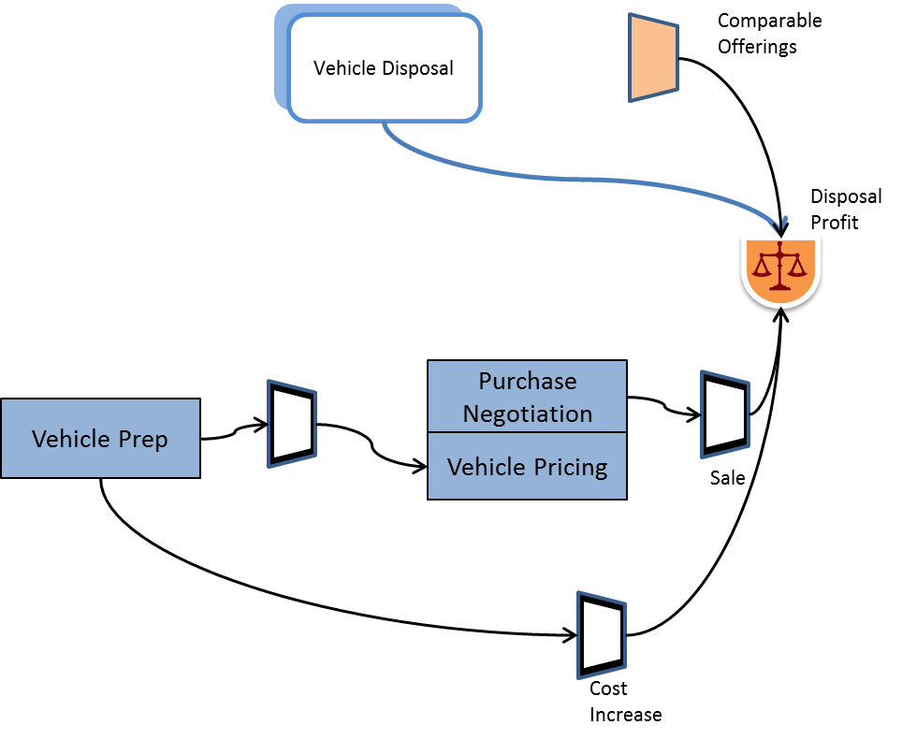
Figure 2.1.6: External Outcomes Influence Achievement of Strategic Objective
Scenario planning is an alternative, dynamic approach to strategy analysis. In this approach, analysts imagine changes in objectives that could be taken by marketplace participants or situational changes that could happen as the consequence of a natural event (e.g., a major flood, an unusually productive harvest, or discovery of a substantial natural resource) or a manmade event (e.g., an economic downturn). Because these changes are external to the enterprise that is the subject of the business architecture, they are typically called "events”.
To evaluate these events, strategy maps are created to realize business value on the occurrence of a particular event. The strategy is implemented when the corresponding event is determined to have taken place, eliminating delay and loss of initiative that would result if the strategic response had not been planned for in advance. The ability to act quickly and decisively in such a situation can produce significant competitive advantage. However, it is important to be clear about the rationale that the occurrence of the event will lead to the opportunity to which the strategy is directed. The possibility that the occurrence of the event will create a hazard for the strategy must also be considered or that the hazard will affect another part of the business adversely.
Scenario planning can be linked to strategy maps by linking the event outcomes to the objectives of the strategy that they support. The resulting strategy map then becomes contingent on observing the event action or its outcome taking place. An example of this approach can be found in The Knowing Organization. Royal Dutch Shell used scenario planning to anticipate the formation of oil cartels and the resulting shortages of 1973, and acquire other strategic reserves. In this case, the event outcome was loss of supply from certain reserves, and the action was the reduction of supplies by cartel nations. A preceding action (and precondition) was the formation of the cartel. The potential outcome of this event was countered by the strategic acquisition of supplies from unaffected reserves according to the contingent strategy.

Norton and Kaplan Strategy Maps and Strategy Initiative Measurement
Because the Norton and Kaplan version of Strategy maps is one of the best known examples of strategy mapping, this approach merits additional attention. These authors are probably best known for another technique, the balanced scorecard. In The Balanced Scorecard: Translating Strategy into Action, the authors observe that most strategic failures result from poor execution, not bad strategy, and they propose the balanced scorecard as a method for managing the implementation of a strategy. This metric-based approach attempts to create strategic alignment by creating a series of hierarchical “scorecards”. Each scorecard gathers together a set of broad metrics that are proxies for the outcomes that an organization or individual is expected to achieve. These scorecards are linked into a hierarchy with dependencies mapped between the levels as illustrated in figure 2.1.7.
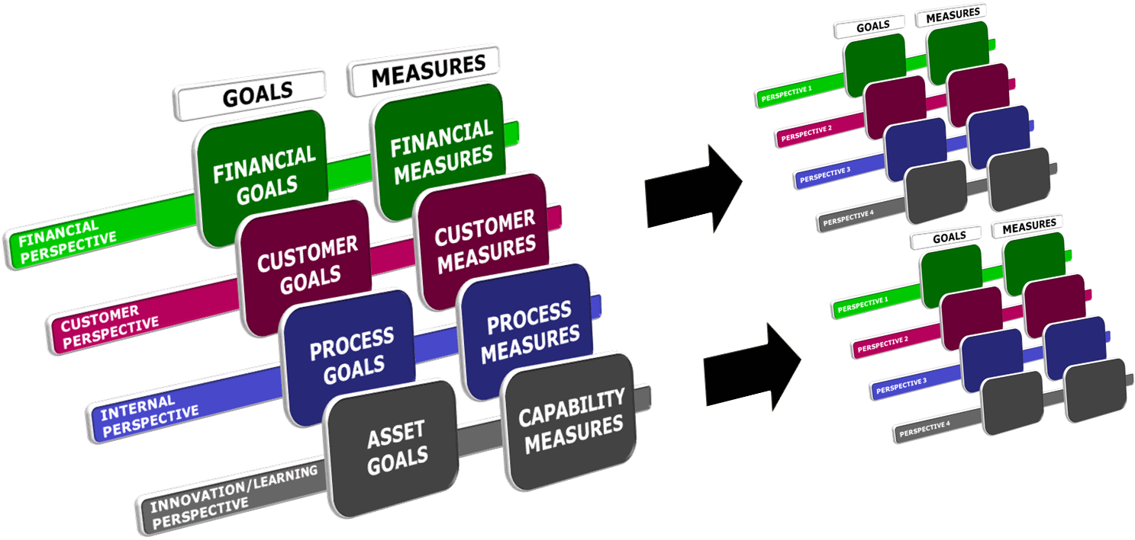
Source: Neal McWhorter
Figure 2.1.7: Balanced Scorecard Hierarchies
To ensure that the metrics capture a broad range of the capabilities needed by the organization rather than becoming short-term operationally focused, Norton and Kaplan proposed that a series of “perspectives” be used to provide a broad view of the organization’s goals. They proposed four categories of these metrics: Financial, Customer, Internal, and Innovation/Learning.
In response to experiences in applying the balanced scorecard, these researchers and consultants produced strategy maps that they used to describe a set of strategic goals. Each set of strategic goals was tied to one of the four perspectives: Financial, Customer, Internal, and Innovation/Learning. This integrated set of perspectives is shown in figure 2.1.7.
An important objective of Kaplan and Norton Strategy Maps is to enable the construction of balanced scorecards. Each objective maps back to a set of metrics on the balanced scorecard. This approach offered the ability for strategic objectives and metrics to be married to each other, enabling organizations to better understand how the metrics they were setting as targets related to and supported the organization’s objectives.
The Norton and Kaplan approach, exemplified in the sample strategy map in figure 2.1.8, has several additional similarities to the techniques outlined in the BIZBOK® Guide. Their strategy maps include a customer perspective that has strong parallel to the value analysis approach that is discussed in section 2.4 of the BIZBOK® Guide. However the approach outlined by Norton and Kaplan does not provide a rigorous framework for how to develop and define value streams, nor does it tie them back to market decisions and environment forces.
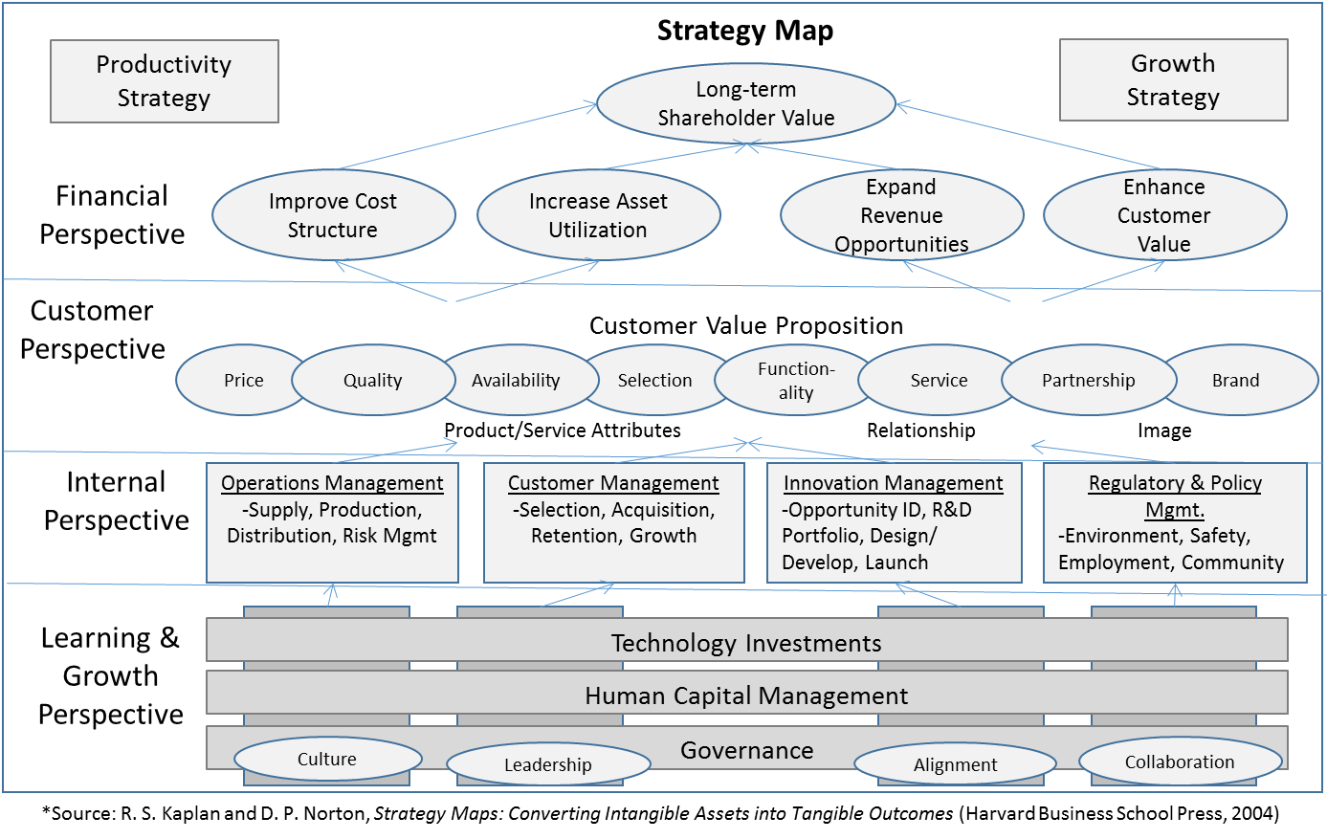
Figure 2.1.8: Sample Strategy Map
The Internal perspective provides a rudimentary approach to tying operational/process metrics back to strategy but does not offer a rigorous approach to how to link the two sets of metrics, nor does it provide guidance about how to resolve conflicts between strategic and operational objectives. Finally, the Learning and Growth perspective offers a rudimentary approach to what has now emerged as the discipline of capability modeling. Many organizations have struggled with this perspective because they lack understanding of how to combine this “enabling” perspective with the other three outcome-based perspectives.
Whether an organization chooses the balanced scorecard approach or another approach to managing strategic initiatives, the method of linking objectives to outcomes and identifying leading and lagging measures that indicate whether or not they are being obtained is important. A strategy without measures of accomplishment is a "hope" and not a manageable strategy. The task for the business architecture practitioner is to carry out an analysis to extract positive and negative, leading and lagging measures from the strategy map initiatives and outcomes and link those measures to the strategy map. This task is typically performed after business stakeholders define and accept an initial strategy portfolio in principle and often performed while elaborating the strategy portfolio to identify business value and feasibility. Section 3.7, Performance Management, further discusses the balanced scorecard topic.

Formalizing the Mapping of Strategy within the Business Ecosystem
There are multiple approaches for tying aspects of business strategy into the larger business ecosystem using business architecture as the overarching framework. As indicated previously, strategy is readily incorporated into the overall business architecture ecosystem and represented as part of the extended business architecture. This section provides perspectives and approaches for tying strategy to other aspects of the business by discussing the Business Motivation Model, basic framework mapping between strategy and other business architecture artifacts and concepts, and use of the Hoshin Kanri framework for mapping formalization.

Business Motivation Model
The Object Management Group’s Business Motivation Metamodel (BMM), shown in figure 2.1.9, attempts to unify strategic concepts into a formal structure. A metamodel is a template that defines the element and relationship types that are allowed to be used in a model. Consequently, architects that use the BMM will typically use only the parts of it that they need, and combine the resulting models with other models that contains elements and relationships not available in the BMM. For example, strategies/goals and tactics/objectives are the most commonly used elements of the BMM. BMM does not address integration with capabilities, value, and information. The architect must provide those linkages outside of the BMM-based model.
Figure 2.1.9: Business Motivation Model
The BMM official standard provides an overview of this concept and related objectives as follows. “The Business Motivation Model provides a scheme or structure for developing, communicating, and managing business plans in an organized manner. Specifically, the Business Motivation Model does all of the following:
- Identifies factors that motivate the establishing of business plans
- Identifies and defines the elements of business plans
- Indicates how all these factors and elements inter-relate.”
The BMM has three useful attributes. First, it is simple enough for the practitioner to apply its basic precepts, even if it is not always taken literally in practice. In practice, teams have used a subset of concepts in the BMM to link the ends to be achieved (i.e., measurable objective and overall goal) to the strategy and tactic (i.e., the means to achieving those ends). Many teams have found this a useful exercise in identifying measurable objectives, which are directly linked to tactics. Teams have additionally found the BMM useful at identifying measurable objectives not only for high level strategies, but as they are refined at the initiative level as well.
Where BMM stumbles, however, is in limiting the tie-in to the business ecosystem to what is shown in figure 2.1.9 as the “referenced elements of business model defined externally”, which is limited to organization, process, and business rule. This is a significant limitation as it ignores the basic business architecture concepts defined within the BIZBOK® Guide, which include capability, value stream, and information, along with organization. As a result, we recommend that the “referenced elements of business model defined externally” shown in figure 2.1.9 be ignored when tying strategy to the larger business ecosystem.
Second, the BMM can be implemented or incorporated into homegrown business architecture mappings where a team could create its own mappings between strategy and tactic, objective and goal, and other business architecture artifacts such as value stream, capability, information, organization. As we noted in the practitioner discussion above, teams using the BMM in this context should ignore the portion shown on “referenced elements of business model defined externally”.
Finally, because it is an official standard from an international standards organization (i.e., the OMG) it can be used by tool vendors for representing and interchanging a formal perspective on business architecture. Unfortunately, the tie-in to the business ecosystem beyond strategy is not well represented as previously discussed. Therefore, a tool vendor implementing this perspective must understand the strategy / business architecture ecosystem mapping, which is discussed in the topic “Business Strategy to Business Ecosystem Impact Analysis” that follows directly.

Business Strategy to Business Ecosystem Impact Analysis
Tying business strategy to business architecture leverages basic concepts that are generally common or derivable from the strategy mapping incarnations viewed within this section of the BIZBOK® Guide. The idea is as follows. Strategy mapping highlights goals and objectives along with identified actions to be taken to achieve those goals and objectives. If the objectives and actions can be quantified, they can then be mapped to the impacted aspects of business architecture, which in turn provide improved context for establishing deployment initiatives and related solutions. This concept is illustrated in figure 2.1.10.
Figure 2.1.10: Business Strategy, Tactic Derivation Using Business Architecture
The strategy in figure 2.1.10 is to “Achieve complete transparency of a Loan for all internal and external stakeholders”. This strategy in turn includes various business objectives, one of which is shown in figure 2.1.10. In order to achieve the objective, which is “Loan officer is notified of any loan activity for an assigned loan” and address the related business challenge, analysts and business architecture practitioners must identify impacted areas of the business. In this example, two value streams and three capabilities are the centerpiece for analysis.
A starting point for identifying business analysis and issue resolution focal points involves key word association. For example, we know that the strategy and objective in figure 2.1.10 are focused on the “loan” business object. Analysis, therefore, begins with the Loan Management capability, which is the centerpiece of how a loan is managed.
Narrowing the analysis further requires more nuance. The business architecture practitioner can look for concepts like “transparency” within the business strategy statement as an indicator that the case file and routing are probably focal points. The result is that the Case File Management and Pipeline Management capabilities, both children of Loan Management, are involved in the analysis. Finally, notification ties to the Notification capability. These three capabilities are shown under the Business Architecture Impact column of figure 2.1.10. Once practitioners have identified capabilities, they can trace these capabilities back to various value streams, business units, and information concepts using capability cross-mappings.
The relationships shown in figure 2.1.10 link business strategy and additional business architecture concepts needed to assess the impacts of a strategy, further inform a given strategy, and tie strategy to specific areas of the business for investment purposes. These relationships enable a business to perform funding analysis of cross-business unit initiatives that impact shared capabilities, value streams, and information. These relationships may be expanded where required by a given in-house approach or specific business scenario.
Impact analysis on capabilities and value streams is a major focal point for this mapping perspective. Capability is one, but not the only, focal point for tracking strategy impacts across a business. Strategic impacts on capability are highlighted by following objective and value item to a given capability. The capability then serves as a gateway to highlighting impacts on value streams, business information, business unit, and initiative. Alternatively, an objective may impact a value stream, which then becomes the focal point for issue analysis and identifying related capabilities. This is important for significant and far reaching objectives or strategies that require examining the entire value stream to assess holistic impacts, failure points, and areas slated for improvement or transformation. Value streams provide a window into process improvement, as well as capability analysis that is required to fine tune business impact analysis.
As far as using these integrated impact analysis perspectives, when a given objective touches a capability, value stream, or information concept, the ripple effect may be unknown to executives. The business architecture practitioner can depict the impacts of a given strategy, which may include tracking business artifacts into the IT architecture as discussed in BIZBOK® Guide part 6.
Once these impacts are clearly identified and articulated, management may shift its strategy. For example, if a project is focused on customer improvements for a given division, the cross-business unit analysis provided by value streams, capabilities, and information mappings may trigger the need for a more comprehensive, holistic solution. In other words, the additional perspectives delivered by business architecture often result in management reevaluating and refining its approach and related funding models.

Strategy Deployment – Hoshin-Kanri
Hoshin-Kanri is a strategic management and quality management technique and tool concept popularized in the late 1950s in Japan by Professor Kaoru Ishikawa to implement policy. Hoshin is Japanese for a compass, a course, a policy or a plan indicating purpose or vision. Kanri is Japanese for management control, which in English means policy deployment. The objective to the Hoshin plan is to ensure all employees in an organization understand the long-term goal, organizational initiatives are aligned to the strategy and goals, and that employee objectives work together to make the goal a reality.
Kanri Policy Deployment is a method of developing and aligning business objectives, annual operating plans, targets, and goals. It is designed to address the issues of strategic and operating planning being done in isolation and not aligned across teams. Policy deployment combines breakthrough projects, those with the most impact on strategic direction, with operational plans that also achieve short-term performance. Policy deployment manages long-term requirements by focusing on annual plans that must be met each year to contribute to long-term strategies. The policy deployment process begins when senior management identifies the key issues or “breakthrough objectives” where initiatives will have their greatest impact on achieving business strategies.
As such, Hoshin-Kanri flows well from the Norton Kaplan Strategy Map. Section 2.1 introduced the user to Norton Kaplan Strategy Maps to align organizational activities behind strategies. One of the greatest obstacles to achieving strategic objectives is the inability to drive alignment with those objectives deep into an organization. The Hoshi-Kanri deployment technique facilitates a guiding strategy principle: Business strategies are only as good as the ability to measure progress towards them. This technique also links into approaches outlined in section 2.6 Initiative Mapping.
Consider the following business scenario to create a high performing organizational culture:
- A company’s three-to-five-year strategic plan and vision are communicated
- A strategically important annual “stretch” objective is agreed to
- Management has identified business needs or opportunities which link to the strategy
- Plans are developed to achieve the objective
- Monitoring processes are established and used to ensure planned actions are accomplished
- Metrics are used to assess progress and to determine if the objective has been achieved
- Year-over-year lessons learned are used to continually improve the planning process
Hoshin Kanri follows a seven-step process that begins with strategy, ties strategy to objectives, aligns objectives to measurable goals, and maps goals to initiatives. The use of this technique establishes a clear organizational message about what is important and ensures less important projects do not compete for the same resources as those needed to enable strategy.
Figure 2.1.11 is a “Hoshin-Kanri Lite” version of the Strategy Deployment Matrix used to communicate the breakthrough strategic objectives down through the organization in terms of specific initiatives and objectives.
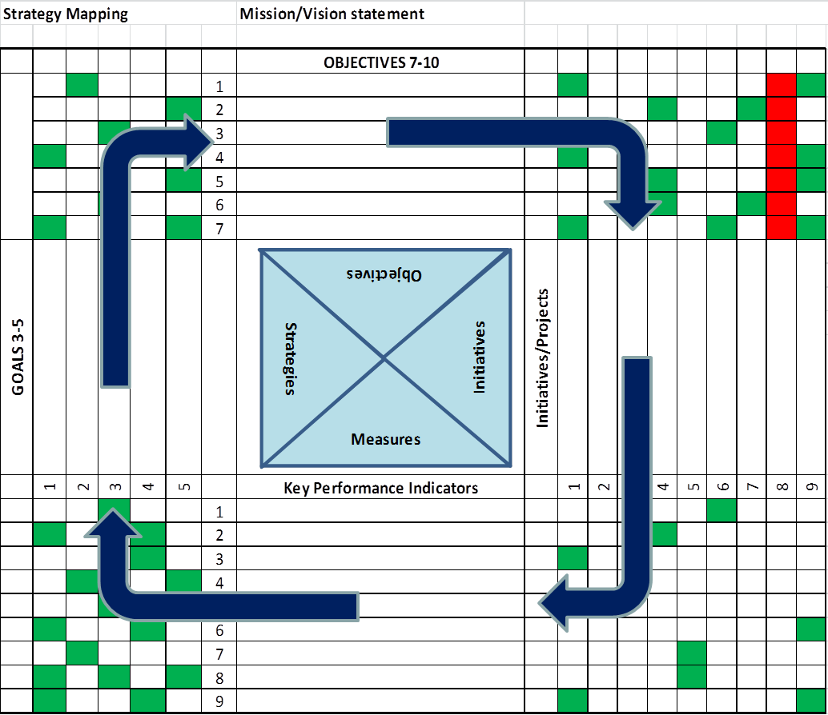
Figure 2.1.11: Tiered Objectives and Activities Mapping
The matrix aligns initiatives to objectives, where each recommended initiative must demonstrate the impact on objectives. Each initiative in turn has an impact on key performance indicator and each performance indicator ties back to a strategic goal. Management can then assess business cases based on total impact and funding allocated against a prioritized list of initiatives that move the organization toward a strategic goal.
Hoshin-Kanri provides a basis for taking the outcomes of a strategy mapping effort and managing the deployment of related initiatives. It provides a management complement to the cross mappings between strategies, capabilities, and initiatives. The tie back to strategy and objectives, use of KPIs, and mapping to initiatives offers another technique for managing strategy deployment.

Summary
Strategy mapping is a field that has been the focus of many significant efforts at formalization. These approaches involve linking value, capabilities, action/outcome, and the environment. Each of these four areas can be used as the point of entry into a strategic evaluation and the choice of approaches is driven by the specifics of a particular organization.
By creating an integrated framework for strategy, organizations enable themselves to rapidly communicate their core values and objectives. A framework also establishes a way for innovation to be identified from within an organization and for potential differentiators to be explored. Using value analysis in combination with environmental evaluations allows for the clear identification of the stakeholders who would benefit from pursuing objectives. Finally, the integration with capabilities allows identification of target investment opportunities based upon the identified opportunities for differentiation.
The definition of this integrated framework is a fundamental step forward toward gaining superior value from the existing strategic approaches. The business architecture knowledgebase provides a way for organizations to provide the structure to support exactly this kind of dynamic, evolving repository of how an organization is defining and pursuing its objectives.

Value analysis refers to the general set of techniques for determining whether and how value is created. Its use in this document should not be confused with the specific technique called “value analysis” or “value engineering” that was developed at GE during World War II.
J. B. Quinn, “Strategies for Change: Logical Incrementalism”, Academy of Management Review (Homewood, IL: Richard D. Irwin, Inc., 1980).
Osterwalder, A. The Business Model Ontology: A Proposition in a Design Science Approach, Ph.D. Thesis, Université de Lausanne, 2004.
Osterwalder, A., Pigneur, Y., Clark, T., Business Model Generation: a handbook for visionaries, game changers, and challengers, Wiley, Hoboken, N.J., 2010.
Harvard Business Review survey of 1000 executives, 2010.
P. Leinwand & C. Mainard, The Essential Advantage: How to Win With a Capabilities-Driven Strategy (Boston: Harvard Business School Press, 2011).
I.H. Ansoff. “Strategies for Diversification”. Harvard Business Review (September/October 1957).
“The Five Competitive Forces That Shape Strategy”, Harvard Business Review, Jan. 2008.
R. S. Kaplan and D. P. Norton, Strategy Maps: Converting Intangible Assets into Tangible Outcomes (Boston: Harvard Business School Press, 2004).
Business Motivation Model (BMM), Object Management Group, 1997-2013, www.omg.org/spec/BMM.
Hoshin Kanri: Visual Strategic Mapping, Hoshin Kanri: Visual Strategic Mapping, 1997-2013, http://www.hoshinkanripro.com.
M. Lagace, “Mapping Your Corporate Strategy”, Harvard Business Review, Harvard Business School, 2004, http://hbswk.hbs.edu/item/3888.html.
R. Rollinson and E.Young, Strategy in the 21st Century (Chicago: LookingGlass Publishing, 2010).
I.H. Ansoff. “Strategies for Diversification”. Harvard Business Review (September/October 1957).
E.P. Learned, C.R. Christiansen, K. Andrews & W.D. Guth, Business Policy, Text and Cases (Homewood, IL: Richard D. Irwin, Inc., 1969).
M. E. Porter, Competitive Strategy: Techniques for Analyzing Industries and Competitors (New York: Free Press, 1980).
R. S. Kaplan and D. P. Norton, Strategy Maps: Converting Intangible Assets into Tangible Outcomes (Boston: Harvard Business School Press, 2004).
M. E. Porter, Competitive Advantage: Creating and Sustaining Superior Performance (New York: Free Press, 1985).
R. S. Kaplan and D. P. Norton, Strategy Maps: Converting Intangible Assets into Tangible Outcomes (Boston: Harvard Business School Press, 2004).
Howard Smith, Introducing PTRIZ, 2006, http://trizmethods.blogspot.com/2006/01/introducing-p-triz.html.
Eliyahu M. Goldratt, What is this thing called Theory of Constraints and How Should it be implemented? (Barrington, MA: North River Press, June 1990).
Thomas L. Saaty, Fundamentals of Decision Making and Priority Theory with the Analytic Hierarchy Process, Vol . 4, 2nd ed. (Pittsburgh: RWS Publications, 2006).
Wikipedia, Analytic Network Process, http://en.wikipedia.org/wiki/Analytic_network_process
Wikipedia, Quality Function Deployment, http://en.wikipedia.org/wiki/Quality_function_deployment
C. W. Choo, The Knowing Organization: How Organizations Use Information to Construct Meaning, Create Knowledge, and Make Decisions, 2nd ed. (New York: Oxford University Press, 2006) 24-27.
Business Motivation Model, Version 1.1, Object Management Group, May 2010, http://www.omg.org/spec/BMM/1.1/PDF/
See BIZBOK® Guide sections 2.3, 2.4, and 2.5 for capability cross-mappings to business unit, value stream, and information.

